**Department of Computer Science**

Mid Term Project Proposal, Summer 22-23

|  |  |  |  |
| --- | --- | --- | --- |
| Course Title | WEB TECHNOLOGIES | Section | K |

**Group Members:**

|  |  |  |  |
| --- | --- | --- | --- |
| Student ID | Name | Signature | Contribution |
| 20-44227-3 | S.M MOINUL ISLAM | Moinul | Admin |
| 20-42643-1 | MIRZA MD TAWHID | Tawhid | Manager |
| 20-43690-2 | MIHADUR RAHMAN SIAM | Siam | Seller |
| 19-41197-2 | MD AKIB AL AHSAN | Akib | User |

**Project Title:**

|  |
| --- |
| **Online Movie Ticketing System** |

**Short Description:** This Project is About online movie ticketing system. This system is being developed to easily collect tickets online to get rid of the trouble of standing in traditional queues, wasting extra time and collecting tickets. Through this system, a user will be able to login, register, select favorite movies, edit their profile, get notifications of new and trending movies and updates easily from the comfort of their own home. Admin can modify the entire system, monitor the information of managers, users, sellers, and provide immediate solutions to any problems. There are four types of users: Admin, Seller, Customer, Manager

|  |
| --- |
| Four types of users: 1. Admin 2. Seller 3. Customer 4. Manager  Common Features for all users:  1.All users can Login to the system  2.Can register to the system.  3.Can manipulate their profile information (edit-delete-view etc.)  4.Also can log out.  **Admin** Functionality:  1.Can do log in, log out and registration validation.  2.Can remove manager, user and seller.  3.Can delete notice and also can update notice.  4.Can remove movie and also update it.  5.Can process and reset password  6.Can see all customer/seller/manager information  **Seller** Functionality:  1.Can check availability of ticket.  2.Can sell ticket.  3.Can check seller notice.  4.Can contact with users/customers.  5.Can cancel the ticket.  **Customer** Functionality:  1.Can view homepage  2. Can check availability of ticket.  3.Can buy ticket.  4.Can get notifications.  5.Can make online payment.  **Manager** Functionality:   1. Monitor whole system. 2. Can update the system. 3. Receive complaints from users. 4. Resolves complaints 5. Mange ticket processing system |

**ER Diagram:**

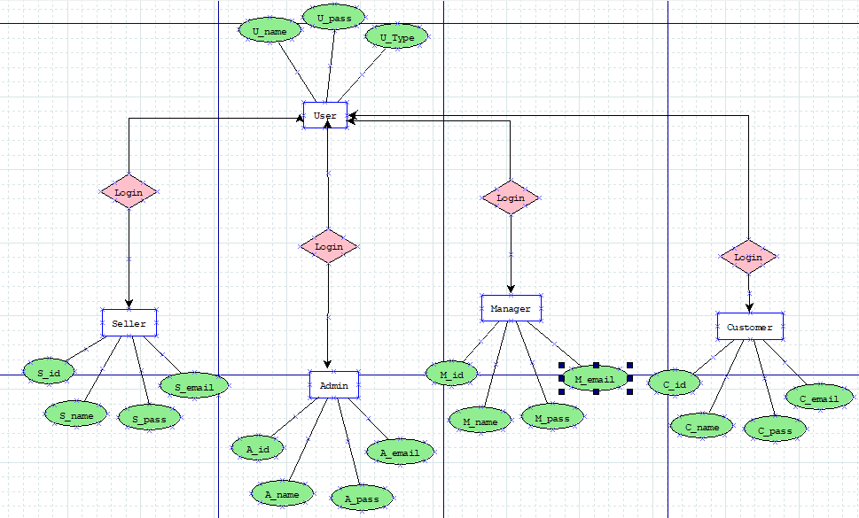

**Existing Website Reference:**

1. <https://ticket.cineplexbd.com>
2. <https://in.bookmyshow.com>
3. <http://www.shyamolicinema.com>